**Jesse Walton**

**Tim Flippen**

**Ryan Kurtz**

**Group 10**

* Everything should be implemented with classes other than the main interface and the definitions of the classes are separated from their implementations – 10%
  1. All classes have proper constructors and destructors and have definitions separated from their implementations.
* Use operator overloading – 5%

**Card** overloads ==

* Use inheritance – 5%

**Game** <- **SlotMachine**

<- **Craps**

<- **CasinoGame** <- **CardGame** <- **Blackjack**

<- **TexasHoldEm**

* Use polymorphism – 5%
  1. **SlotMachine**, **Craps**, **Blackjack** and **TexasHoldEm** are all derived from the abstract class **Game** which has a pure virtual function *play()*. All classes override *play()* to implement their respective game. A **Game** type pointer is created and a switch statement determines which derived class (**SlotMachine**, **Craps**, **Blackjack** or **TexasHoldEm**) it is assigned to.
* Use template – 5%
  1. **Player** uses the template type for functions *creditPlayer(T amount)* and *debitPlayer(T amount)* with declarations for processing integers and doubles.
* All classes have constructor and destructor – 5%

All classes have constructor and destructor. Destructors handle dynamic memory allocation as needed. Derived classes of **Game** have virtual destructors.

* Use vector – 5%

**CasinoGame**, **CardGame**, **Blackjack**, **TexasHoldEm** and **Craps** all contain vectors (not including inherited vectors).

* Use const and static – 5%

**Blackjack** and **SlotMachine** use static integers to track number of plays. **Player** uses const for all ‘get’ type functions.

* Use new and delete – 5%

**Main** uses new to create derived class objects (**Craps**, **SlotMachine**, **TexasHoldEm** and **Blackjack**) which are pointed to by a base class pointer (**Game**). After assigned, *play()* is called on the base class pointer and then it is deleted. Virtual destructors handle this case.

**CasinoGame** and **CardGame** both use new and delete to dynamically allocate memory. **CasinoGame** dynamically creates arrays to keep track of player bets and game conditions, while **CardGame** dynamically creates an array of vectors to represent each player's hand of **Card**s.

* Report – 50%. Your report should indicate where all the required components are implemented. It also should include an instruction and an example input for testing.

Begin program

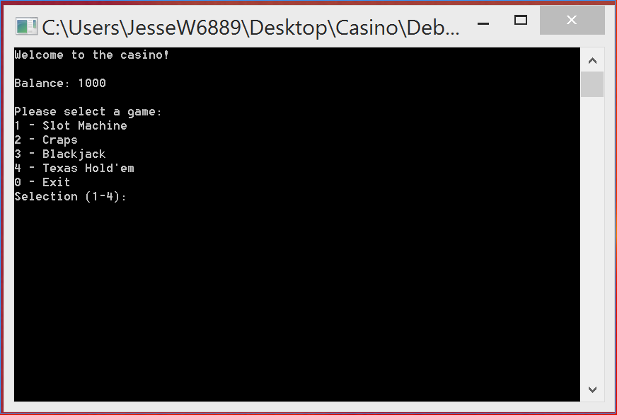

**Input:** 1 [ENTER] (select Slot Machine)

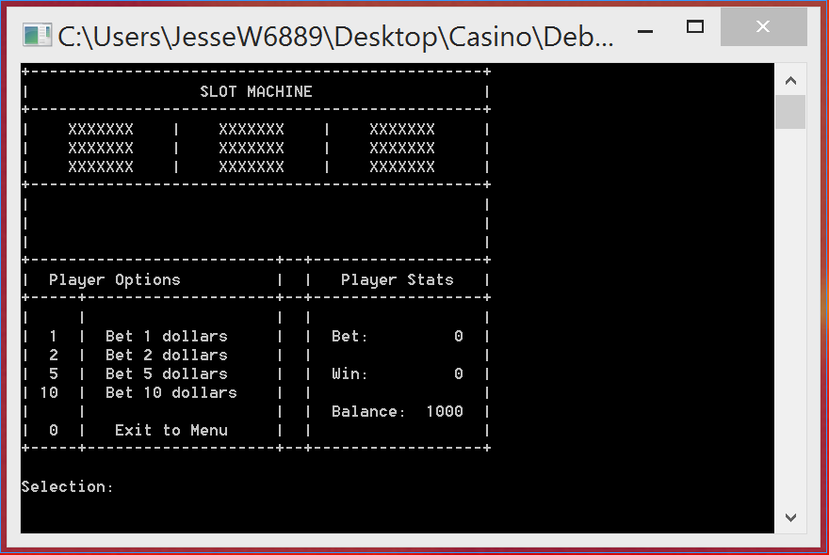

**input:** 10 [ENTER] (bet 10)

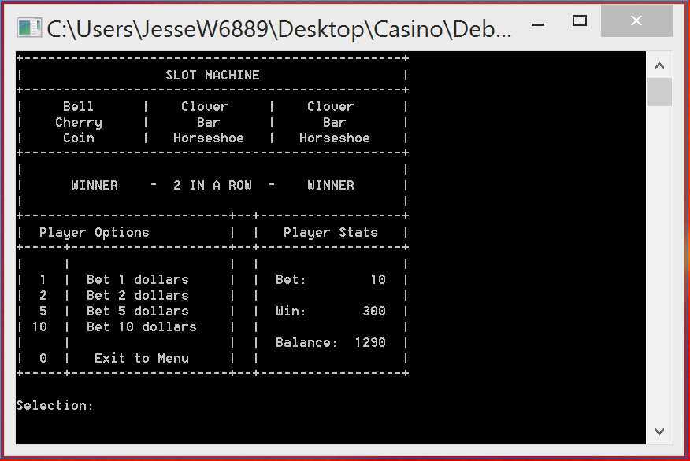

**Input:** 0 [ENTER] (exit slot machine to main menu)

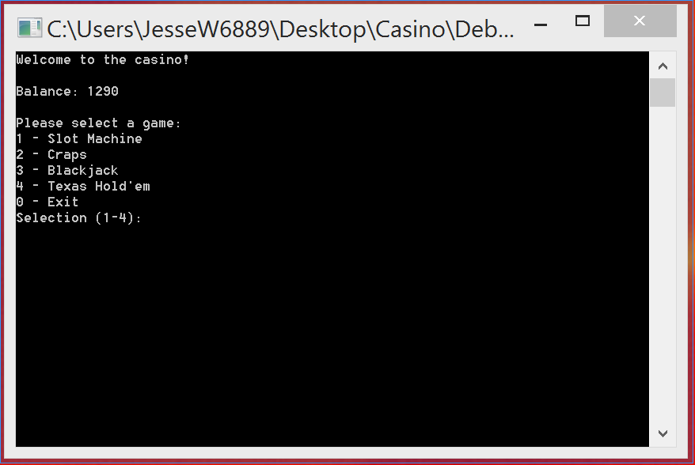

**Input:** 2 [ENTER] (select Craps)

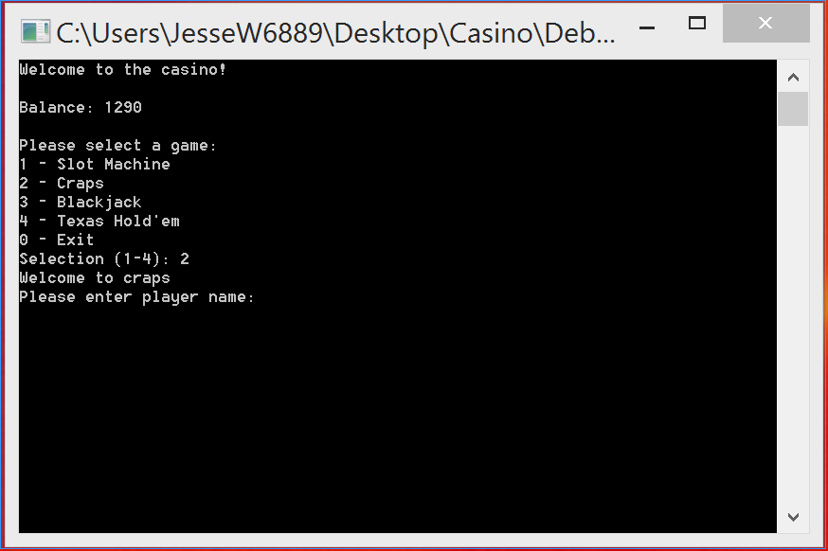

**Input:** Player [ENTER] (player name)

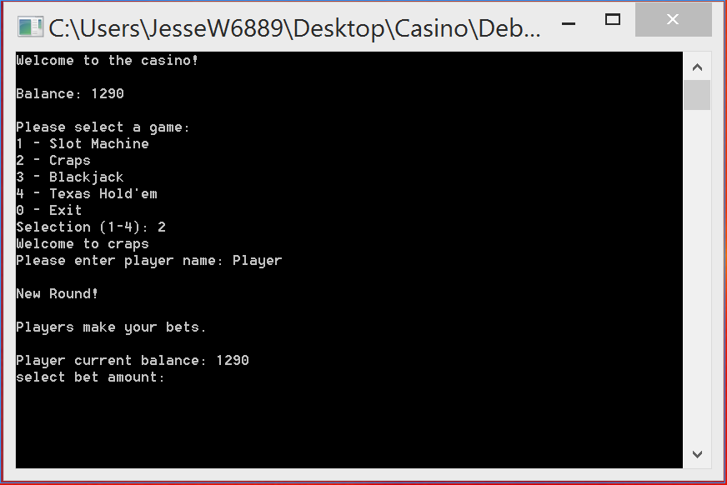

**Input:** 100 [ENTER] (bet 100)

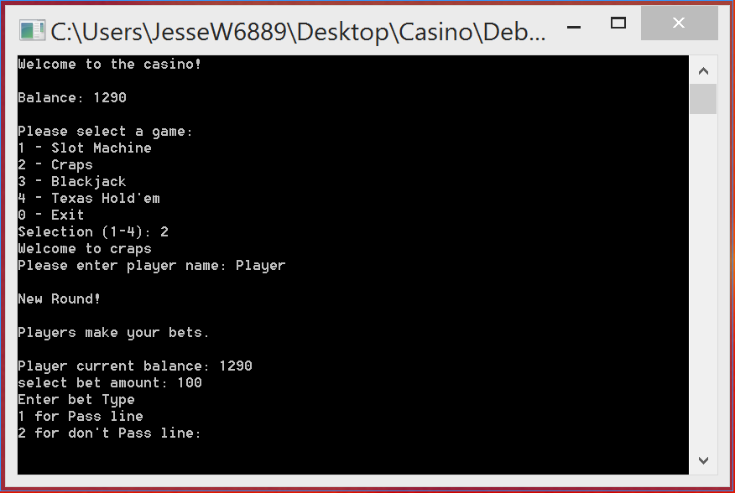

**input:** 1 [ENTER] (select pass line bet type)

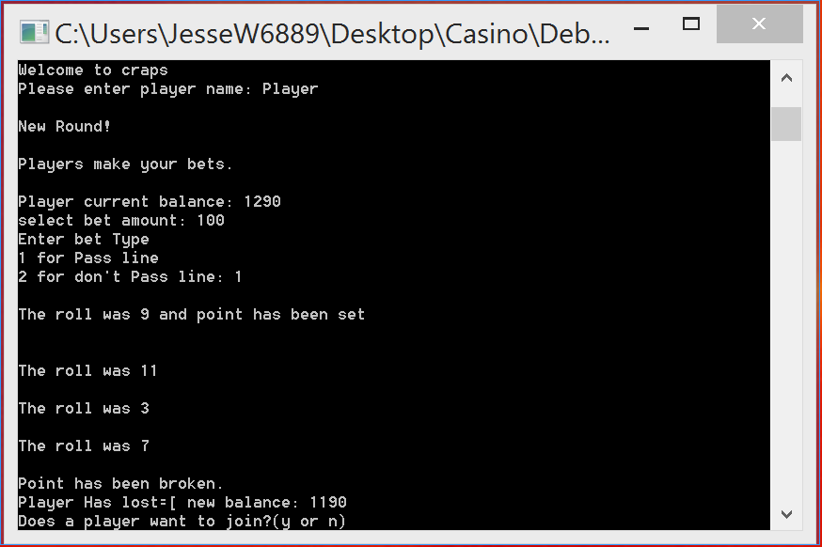

**input:** n [ENTER] (do not add another player)

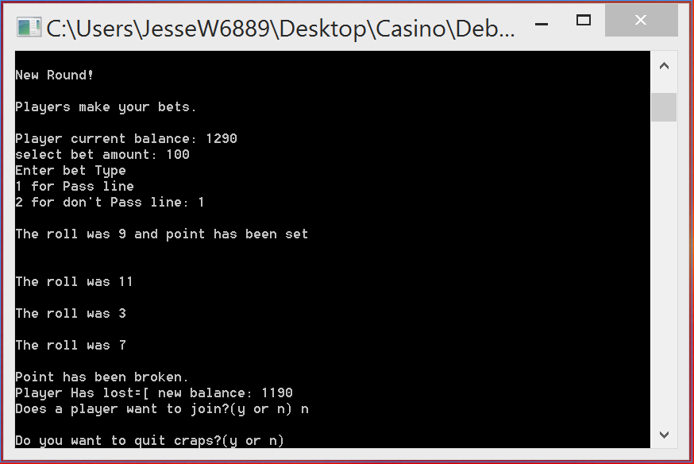

**Input:** y [ENTER] (quit Craps)

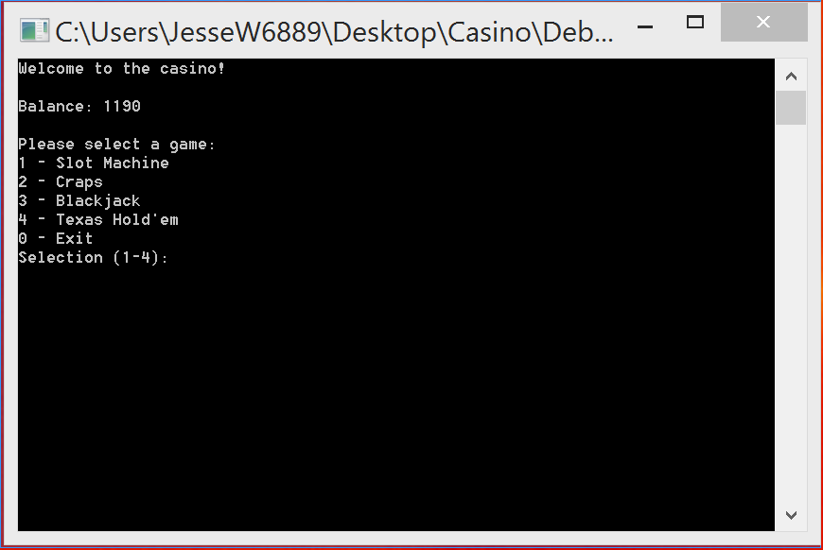

**Input:** 3[ENTER] (select Blackjack)

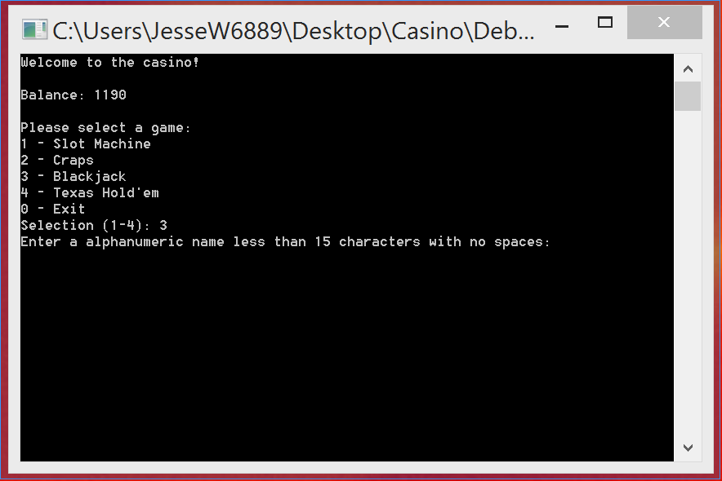

**Input:** Mike [ENTER] (enter player name)

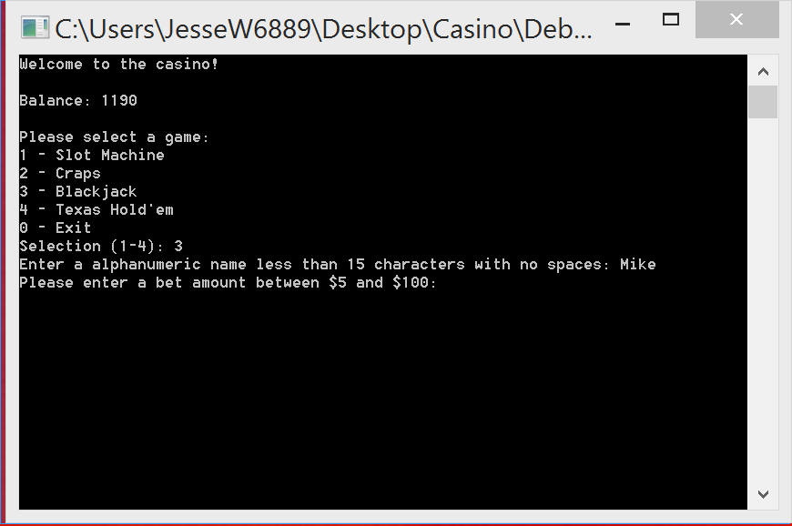

**Input:** 100 [ENTER] (bet 100)

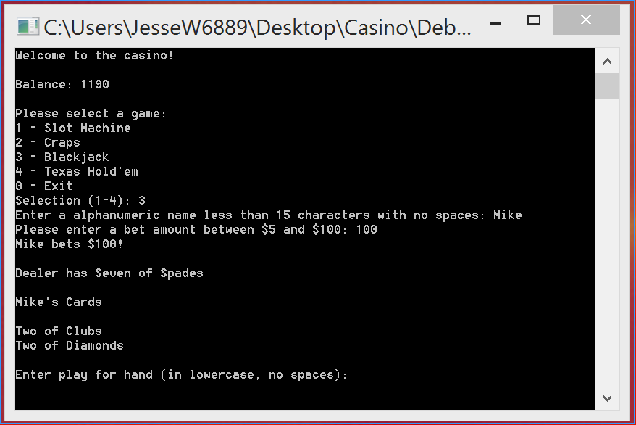

**Input:** hit [ENTER]

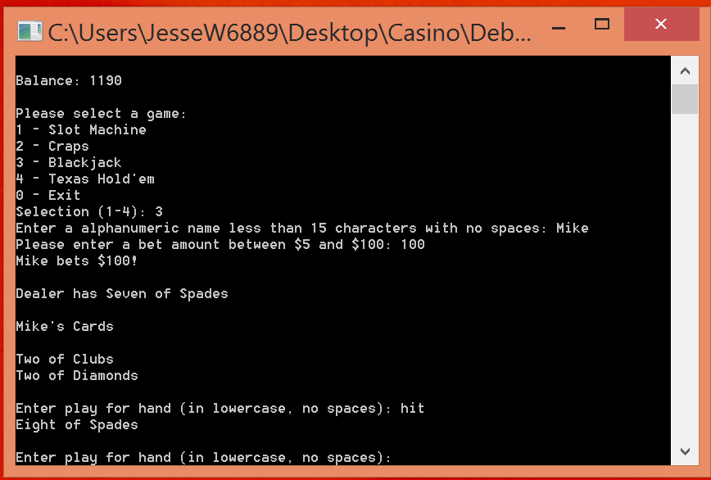

**Input:** hit [ENTER]

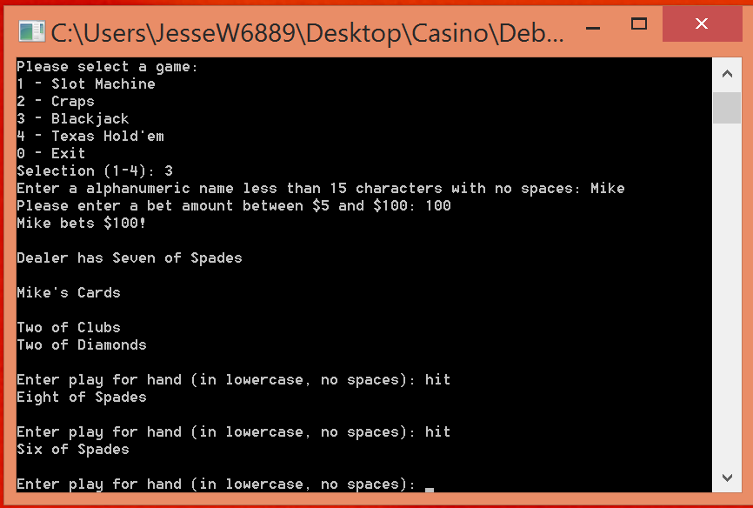

**Input:** stand [ENTER]

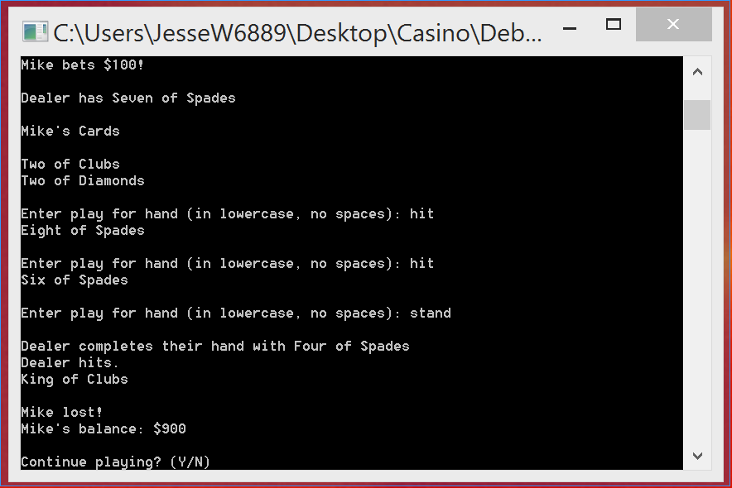

**Input:** N [ENTER] (exit Blackjack)

**Main Menu:**

Program begins here with a menu. First Player starts with 1000 credits. Options are to select a game or exit program.

**Slot Machine:**

Game begins with generic state slot machine. Options are to chose bet amount or exit to main menu. Upon entering bet amount, credits are deducted from player and slot machine spins. If a winning spin, player gets appropriate amount credited to their balance.

Upon exit, balance carries over to main menu.

**Craps game**

Game begins with player 1 name prompt. Asks for bet amount and bet type. Dice are rolled until point is hit. Credits are awarded as needed. After each round, players are given the option to join/ leave the table and to quit the game.

Upon exit, balance carries over to main menu.

**Blackjack**

Game begins with player 1 name prompt and then bet amount. Dealer’s visible card is displayed along with both player cards. Player is prompted to hit or stand. Dealer goes after player. Winner is determined and credits are distributed as needed.

Upon exit, balance carries over to main menu.